**Relational data**

If we want to featurize relational data then we can do this by SQL or by python pandas which also runs the sql script.

We got relational data from relational database like oracle, MySQL, SQLServer

In below ex: we use 4 tables

1. Customer table
2. Cust viewing : when customer visit product page and on what time
3. Purchase data : at what time customer purchase product
4. Product table

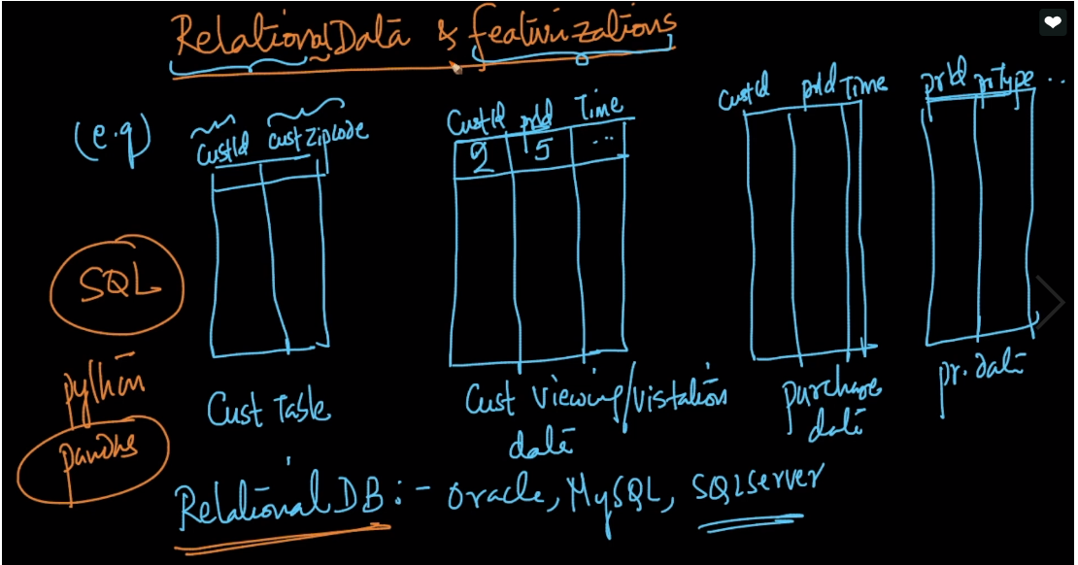

Now our task is to predict if a customer would purchase a product in the next 7 day or not.

So for this task we make a feature vector in which

Feature f1 : no. of times the customer id viewed the product page in 24 hrs.

F2 : no. of times the custId visited any product type as prId . for eg of ecommerce custumer wants to buy :LG tv 50 inch but before buying this customer visits other product similar to this as well like Samsung tv 50 inch

F3 : income level , it also helps to determine purchasing probability because high income purchase high.

F4 : zip-code , its like some areas are posh and there is more purchasing than other areas.

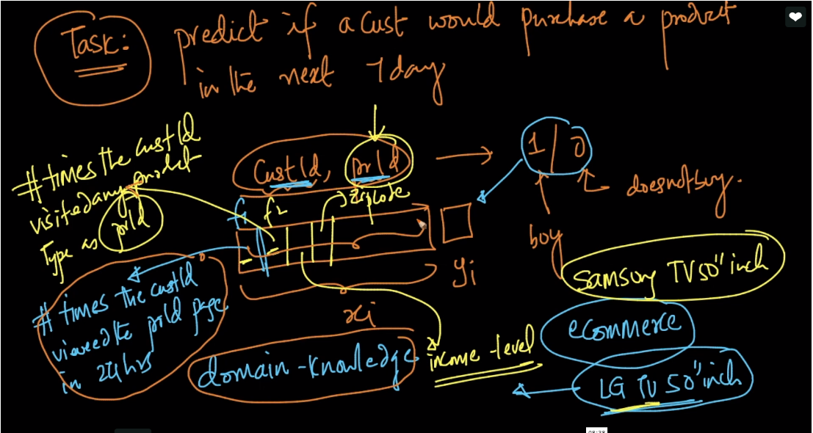

So if we have relational format then we use sql, python along with domain knowledge to featurize

